Overlapping-Figure Composition

Definition
# Source: AI Source: Provided by: [Data Path: Persons Table -> ID Column: 1, Name_En Column: Motasem Essam] -> From: [ChatGPT] on [7/25/2026]
Overlapping-Figure Composition is a type of geometric figure composition in which two or more geometric figures occupy some of the same region of a plane or space, creating an overlapping configuration.
The overlap may produce a new visible outline, a shared interior region, or a composite arrangement whose total area must account for the intersection.

Simple Definition
# Source: AI Source: Provided by: [Data Path: Persons Table -> ID Column: 1, Name_En Column: Motasem Essam] -> From: [ChatGPT] on [7/25/2026]
Overlapping-figure composition means combining geometric figures so that part of one figure lies within the region occupied by another figure.
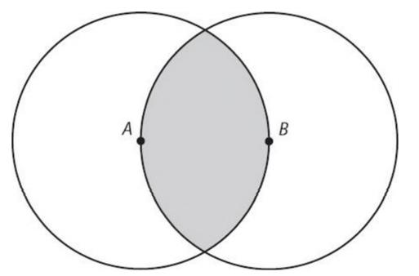
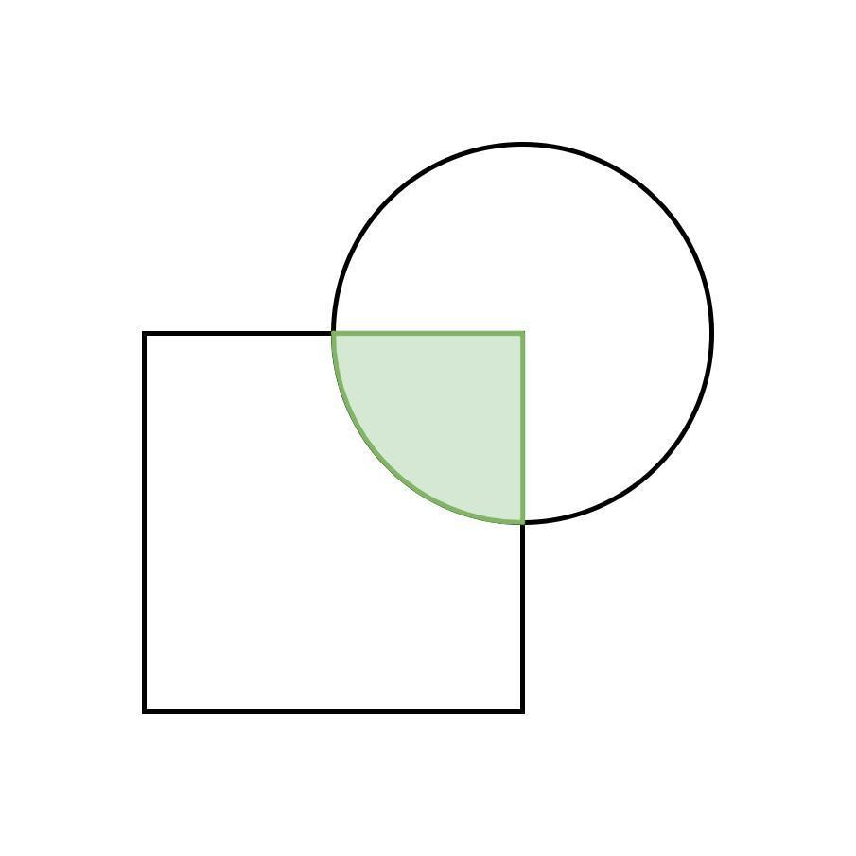
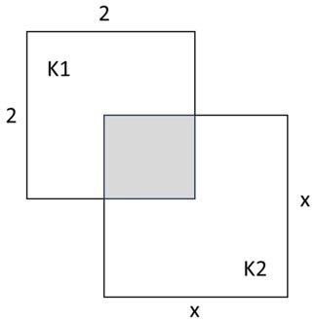

Main Classification
# Source: AI Source: Provided by: [Data Path: Persons Table -> ID Column: 1, Name_En Column: Motasem Essam] -> From: [ChatGPT] on [7/25/2026]
The following is a practical classification based on the shapes and nature of their overlap. These categories are descriptive rather than a universally standardized taxonomy, and they can overlap.

1. Circle–Circle Overlapping Composition
# Source: AI Source: Provided by: [Data Path: Persons Table -> ID Column: 1, Name_En Column: Motasem Essam] -> From: [ChatGPT] on [7/25/2026]
Two circular regions overlap, creating a lens-shaped intersection when their boundaries cross at two points.
Example: Two equal circles whose centers are closer than twice their radius but farther apart than zero.
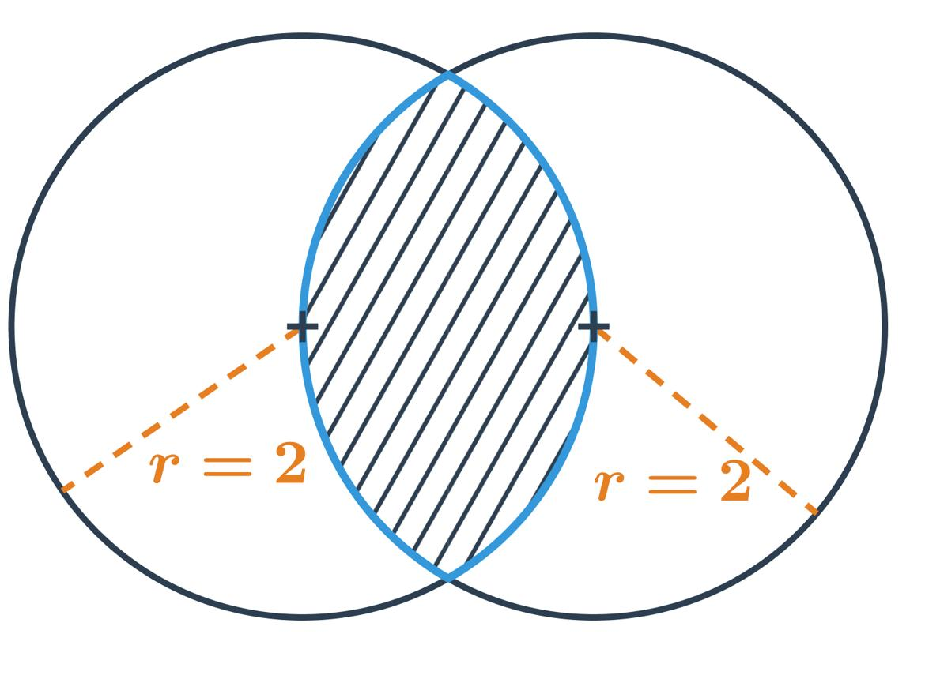
Detailed Explanation and Examples
Definition: Two circular regions overlap when they share a common region.
Let the circles have radii $r_{1}$and $r_{2}$, and let the distance between their centers be $d$.
- If $d>r_{1}+r_{2}$, their regions are separate.
- If $d=r_{1}+r_{2}$, they are externally tangent and share only one point.
- If $∣r_{1}-r_{2}∣<d<r_{1}+r_{2}$, their boundaries cross at two points and their regions overlap partially.
- If $d≤∣r_{1}-r_{2}∣$, the smaller disk lies inside or is internally tangent to the larger disk, assuming both radii are positive.
Example: Two circles each have radius $5$units, with centers $6$units apart.
Since
$$0<6<5+5,$$
and $6>∣5-5∣=0$, the circles overlap partially and their boundaries intersect at two points.
For equal circles of radius $r$, separated by distance $d$, the common lens area is
$$A_{\text{overlap}}=2r^{2}\cos^{-1}\left(\frac{d}{2r}\right)-\frac{d}{2}\sqrt{4r^{2}-d^{2}}.$$
For $r=5$and $d=6$,
$$A_{\text{overlap}}=50\cos^{-1}\left(0.6\right)-12≈22.36$$
square units.

2. Polygon–Polygon Overlapping Composition
# Source: AI Source: Provided by: [Data Path: Persons Table -> ID Column: 1, Name_En Column: Motasem Essam] -> From: [ChatGPT] on [7/25/2026]
Two or more polygons share a region of positive area.
Example: Two squares positioned so that part of each lies inside the other.
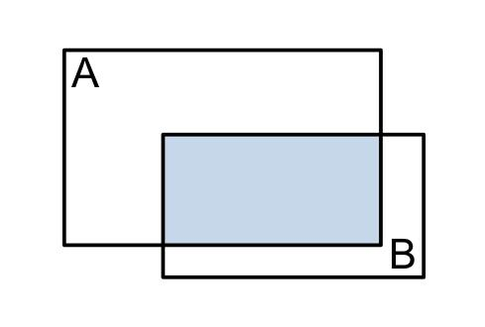
Detailed Explanation and Examples
Definition: Two polygons overlap when their interiors share a region of positive area.
Example: Two squares each have side length $4$units. Suppose they overlap in a $2×2$square.
Each original square has area
$$A_{1}=A_{2}=4^{2}=16.$$
The intersection area is
$$A_{\text{intersection}}=2^{2}=4.$$
The area covered by at least one square is
$$A_{\text{union}}=A_{1}+A_{2}-A_{\text{intersection}}$$
$$\boxed{A_{\text{union}}=16+16-4=28}$$
square units.

3. Mixed-Shape Overlapping Composition
# Source: AI Source: Provided by: [Data Path: Persons Table -> ID Column: 1, Name_En Column: Motasem Essam] -> From: [ChatGPT] on [7/25/2026]
Different types of geometric figures overlap.
Example: A circle overlapping a rectangle, creating a region bounded partly by a circular arc and partly by straight segments.
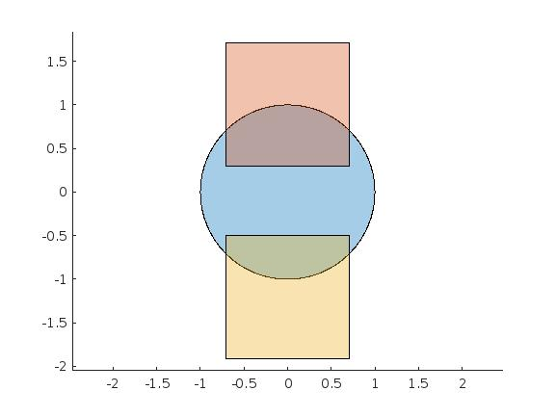
Detailed Explanation and Examples
Definition: Two or more different geometric shape types overlap.
Example: A circle overlaps a rectangle. To find the total covered area, add the circle's area to the rectangle's area and subtract their common area:
$$\boxed{A_{\text{union}}=A_{\text{circle}}+A_{\text{rectangle}}-A_{\text{intersection}}}$$
The intersection may require geometric partitioning, coordinate geometry, or integration to calculate.

4. Multiple-Figure Overlapping Composition
# Source: AI Source: Provided by: [Data Path: Persons Table -> ID Column: 1, Name_En Column: Motasem Essam] -> From: [ChatGPT] on [7/25/2026]
Three or more figures overlap in one or more regions.
Example: Three circles whose pairwise intersections form several distinct regions.
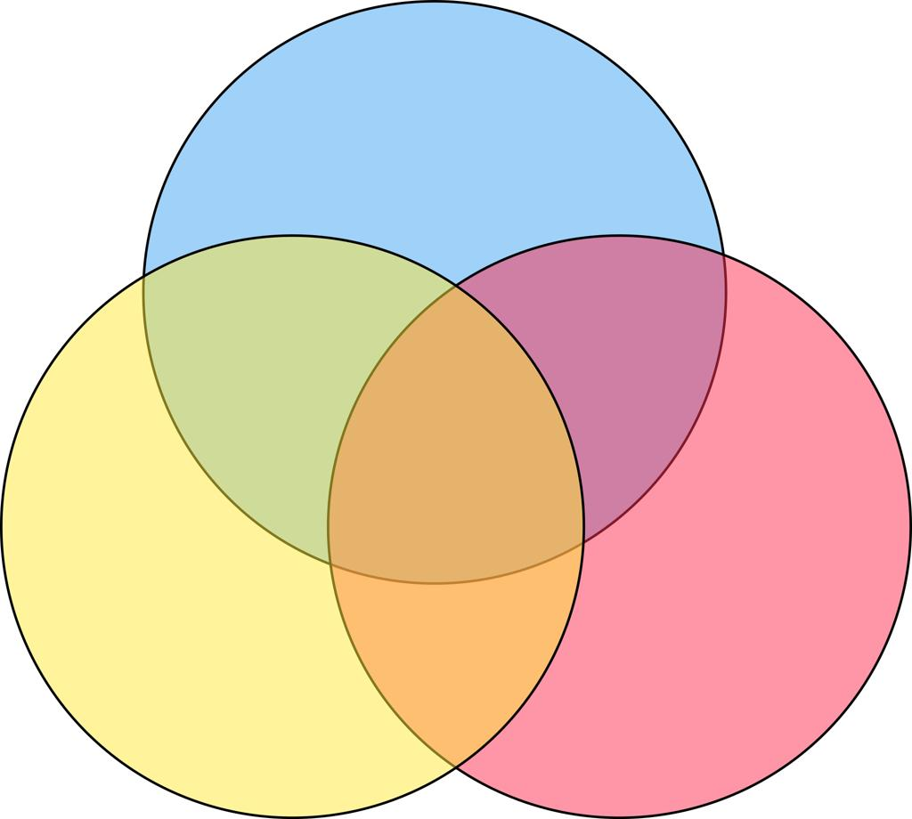
Detailed Explanation and Examples
Definition: Three or more figures overlap, potentially creating several pairwise and shared intersection regions.
Example: Three circular regions $A$, $B$, and $C$overlap.
Their union area follows the inclusion–exclusion principle:
$$\begin{aligned}∣A∪B∪C∣=&∣A∣+∣B∣+∣C∣ \\ &-∣A∩B∣-∣A∩C∣-∣B∩C∣ \\ &+∣A∩B∩C∣.\end{aligned}$$
The triple intersection is added back because it was subtracted too many times in the pairwise terms.

5. Intersection-Region Composition
# Source: AI Source: Provided by: [Data Path: Persons Table -> ID Column: 1, Name_En Column: Motasem Essam] -> From: [ChatGPT] on [7/25/2026]
The common region shared by overlapping figures is the main object of interest.
Example: Finding the lens-shaped region that belongs to both circles.
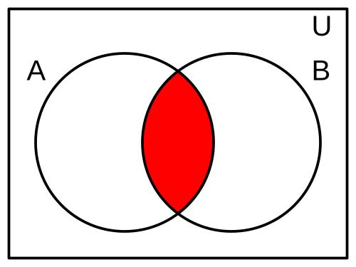
Detailed Explanation and Examples
Definition: The common portion shared by two or more figures is isolated and studied.
In set notation, the intersection of two regions $A$and $B$is
$$A∩B=\left\{P:P∈A\text{ and }P∈B\right\}.$$
Example: The common region of two overlapping disks is a lens. Its area is the part shared by both disks, not the entire area covered by either disk.

6. Union-Based Overlapping Composition
# Source: AI Source: Provided by: [Data Path: Persons Table -> ID Column: 1, Name_En Column: Motasem Essam] -> From: [ChatGPT] on [7/25/2026]
The complete region occupied by at least one of the overlapping figures is considered.
Example: Calculating the total area covered by two overlapping circular regions without counting their common area twice.
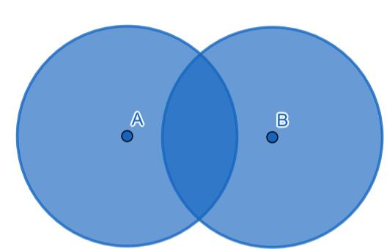
Detailed Explanation and Examples
Definition: The complete region covered by at least one component figure is considered.
In set notation,
$$A∪B=\left\{P:P∈A\text{ or }P∈B\right\}.$$
Example: Two overlapping rectangles cover $20$and $15$square units, and their common region has area $5$square units.
$$A_{\text{union}}=20+15-5=30$$
square units.

7. Partial-Overlap Composition
# Source: AI Source: Provided by: [Data Path: Persons Table -> ID Column: 1, Name_En Column: Motasem Essam] -> From: [ChatGPT] on [7/25/2026]
Only part of each figure overlaps; portions of both figures remain outside the common region.
Example: Two rectangles intersect in a smaller rectangle while each retains an exposed portion.
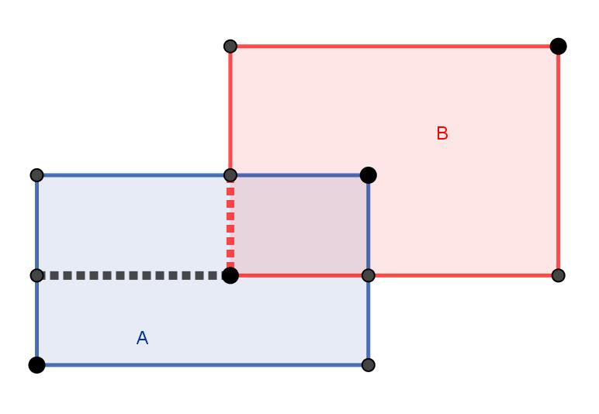
Detailed Explanation and Examples
Definition: Figures overlap in only part of their interiors, leaving other portions outside the intersection.
Example: A horizontal rectangle and a vertical rectangle overlap in a smaller rectangular region. The combined area is
$$A_{\text{union}}=A_{1}+A_{2}-A_{\text{intersection}}.$$
This is the standard area calculation for two partially overlapping regions.

8. Containment-Based Overlap
# Source: AI Source: Provided by: [Data Path: Persons Table -> ID Column: 1, Name_En Column: Motasem Essam] -> From: [ChatGPT] on [7/25/2026]
One figure lies entirely inside another. This is a special containment configuration, often treated separately from crossing overlaps.
Example: A small circular region lies completely inside a larger circular region.
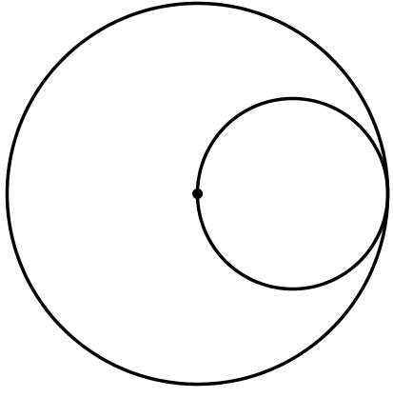
Detailed Explanation and Examples
Definition: One figure lies completely inside another. The smaller region is a subset of the larger region.
Example: A disk of radius $2$lies entirely inside a disk of radius $5$.
For the union of the two disks,
$$A_{\text{union}}=25π,$$
because the smaller disk adds no new area beyond the larger disk.
For the area inside the larger disk but outside the smaller disk, use subtraction:
$$A_{\text{larger minus smaller}}=25π-4π=\boxed{21π}.$$
The containment configuration is sometimes classified as nested or contained composition rather than overlapping composition, depending on the taxonomy being used.

Important Mathematical Rules

Area of Two Overlapping Figures
# Source: AI Source: Provided by: [Data Path: Persons Table -> ID Column: 1, Name_En Column: Motasem Essam] -> From: [ChatGPT] on [7/25/2026]
For two measurable regions $A$and $B$,
$$\boxed{Area⁡\left(A∪B\right)=Area⁡\left(A\right)+Area⁡\left(B\right)-Area⁡\left(A∩B\right)}$$
This prevents the common region from being counted twice.

Three or More Overlapping Figures
# Source: AI Source: Provided by: [Data Path: Persons Table -> ID Column: 1, Name_En Column: Motasem Essam] -> From: [ChatGPT] on [7/25/2026]
For multiple regions, inclusion–exclusion accounts for pairwise, triple, and higher-order intersections. Simply subtracting all pairwise intersections is not sufficient when three or more regions share common areas.

Boundary Contact vs. Area Overlap
# Source: AI Source: Provided by: [Data Path: Persons Table -> ID Column: 1, Name_En Column: Motasem Essam] -> From: [ChatGPT] on [7/25/2026]
Two figures can touch at a point or along a line segment without sharing any area of positive size.
- Point contact: the intersection is a point.
- Edge or boundary contact: the intersection is a segment or curve.
- Interior overlap: the intersection has positive area in the plane.
In ordinary area calculations, point or line contact contributes zero area.

Overlapping-Figure Composition vs. Related Concepts
# Source: AI Source: Provided by: [Data Path: Persons Table -> ID Column: 1, Name_En Column: Motasem Essam] -> From: [ChatGPT] on [7/25/2026]
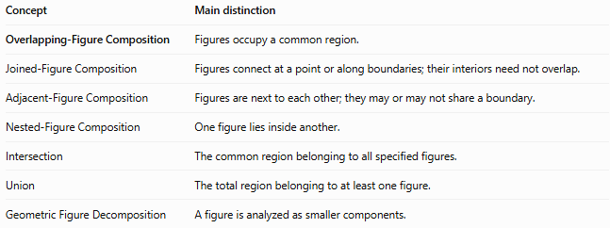
Concept | Main distinction
Overlapping-Figure Composition | Figures occupy a common region.
Joined-Figure Composition | Figures connect at a point or along boundaries; their interiors need not overlap.
Adjacent-Figure Composition | Figures are next to each other; they may or may not share a boundary.
Nested-Figure Composition | One figure lies inside another.
Intersection | The common region belonging to all specified figures.
Union | The total region belonging to at least one figure.
Geometric Figure Decomposition | A figure is analyzed as smaller components.

Classification Summary
# Source: AI Source: Provided by: [Data Path: Persons Table -> ID Column: 1, Name_En Column: Motasem Essam] -> From: [ChatGPT] on [7/25/2026]
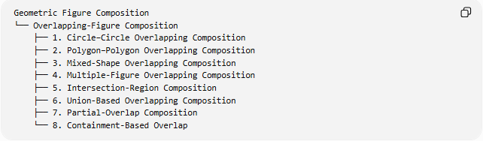
Geometric Figure Composition
└── Overlapping-Figure Composition
├── 1. Circle–Circle Overlapping Composition
├── 2. Polygon–Polygon Overlapping Composition
├── 3. Mixed-Shape Overlapping Composition
├── 4. Multiple-Figure Overlapping Composition
├── 5. Intersection-Region Composition
├── 6. Union-Based Overlapping Composition
├── 7. Partial-Overlap Composition
└── 8. Containment-Based Overlap
These are practical descriptive categories rather than mutually exclusive mathematical classes. For example, a circle and rectangle may have both a partial overlap and a mixed-shape overlap.

Key Points
# Source: AI Source: Provided by: [Data Path: Persons Table -> ID Column: 1, Name_En Column: Motasem Essam] -> From: [ChatGPT] on [7/25/2026]
- Overlapping figures share a common region, often with positive area.
- The intersection identifies the shared region; the union identifies the complete covered region.
- For two overlapping regions, subtract the intersection area when calculating their union.
- Multiple overlaps require the inclusion–exclusion principle.
- Containment is a special positional relationship and may be classified separately from partial overlap.
- Touching at a boundary does not necessarily mean the figures overlap in area.

Conclusion
# Source: AI Source: Provided by: [Data Path: Persons Table -> ID Column: 1, Name_En Column: Motasem Essam] -> From: [ChatGPT] on [7/25/2026]
Overlapping-Figure Composition describes geometric configurations in which two or more figures share part of the same region. It is especially useful for calculating combined areas, studying intersections and unions, analyzing circular lenses, and solving problems involving multiple overlapping shapes.

